BE PART OF THE
LIGHT OF THE WORLD JOURNEY
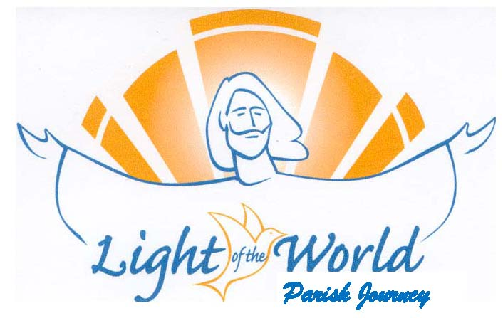
HAVE A PERSONAL ENCOUNTER
WITH JESUS CHRIST
THROUGH THE POWER OF THE HOLY SPIRIT!

OCTOBER 18 – 21, 2019
Transfiguration Parish Office
316 W. Mill St. Wauconda

Friday, October 18, 6:30 pm – 8:30 pm
Saturday, October 19, 8:00 am – 6:00 pm
Sunday, October 20, 8:00 am – 5:30 pm
Monday, October 21, 6:30 pm – 8:30 pm
18 years & older
No Cost All Meals provided No overnights
Questions? To Register:
Call Mary Ann Fijalkiewicz, 847-997-7101
Or email : maryannfij@yahoo.com

KNOW AND LIVE GOD’S PLAN FOR YOU!

